**Evan Pulido**

**ITSC 3155**

**1.Print out all the student first names and last names.**

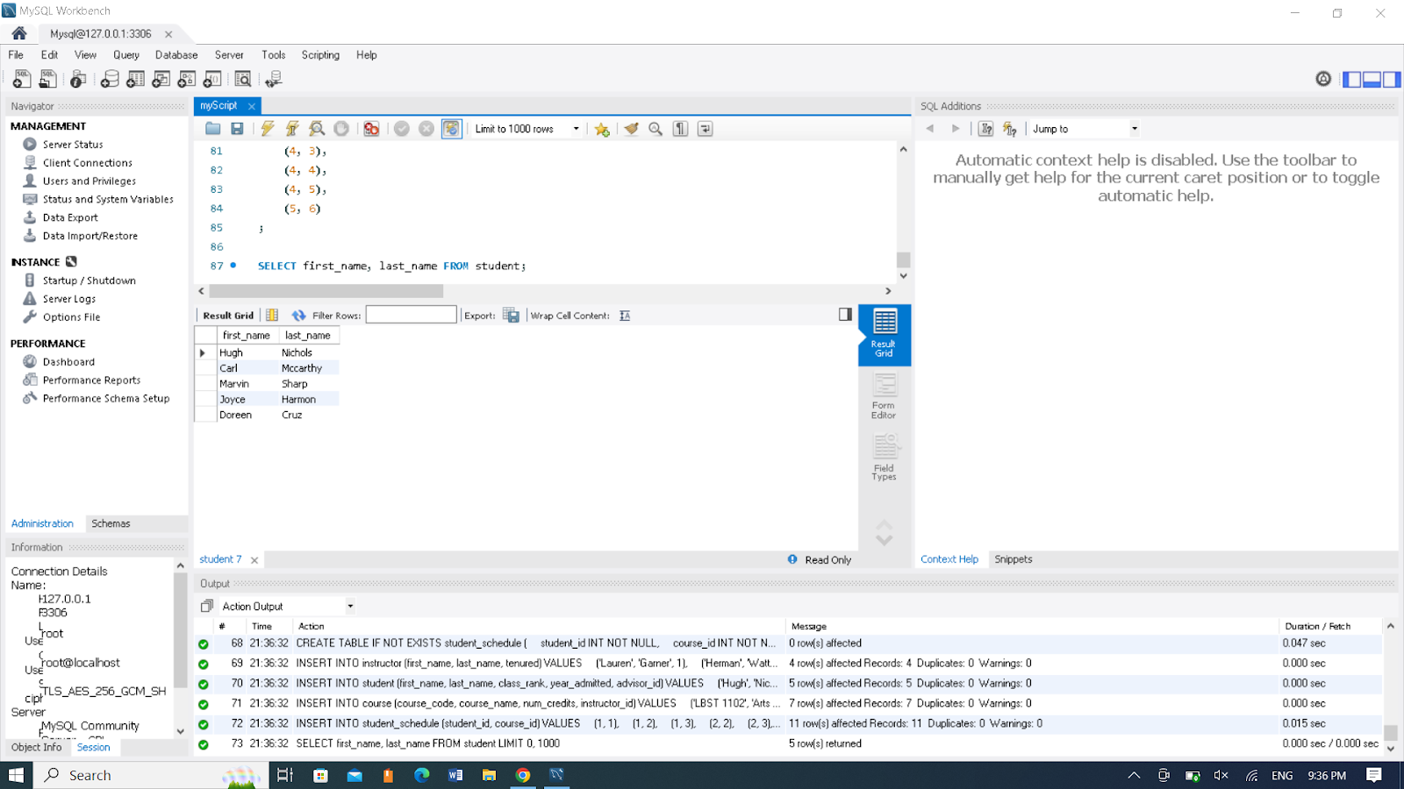

**2.Print out the IDs of all the tenured instructors.**

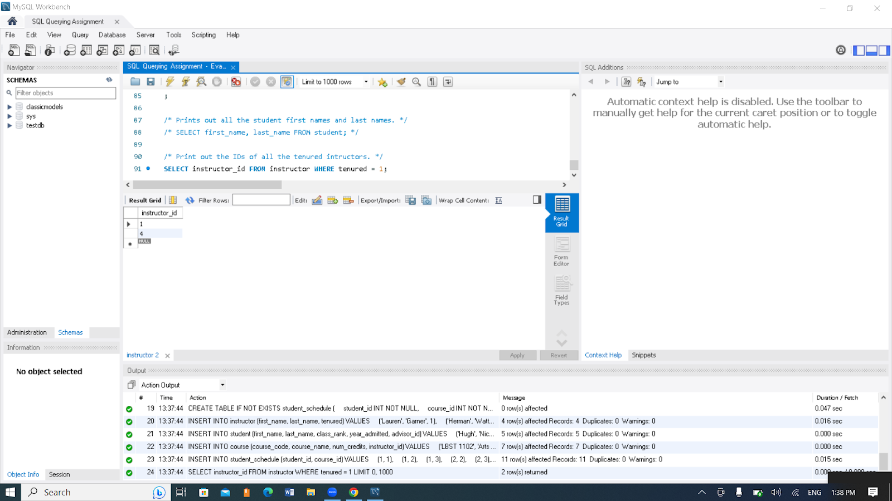

**3.Print out the student’s first and last names along with their advisor’s first and last names. Have descriptive column names. Exclude students without advisors and advisors without students.**

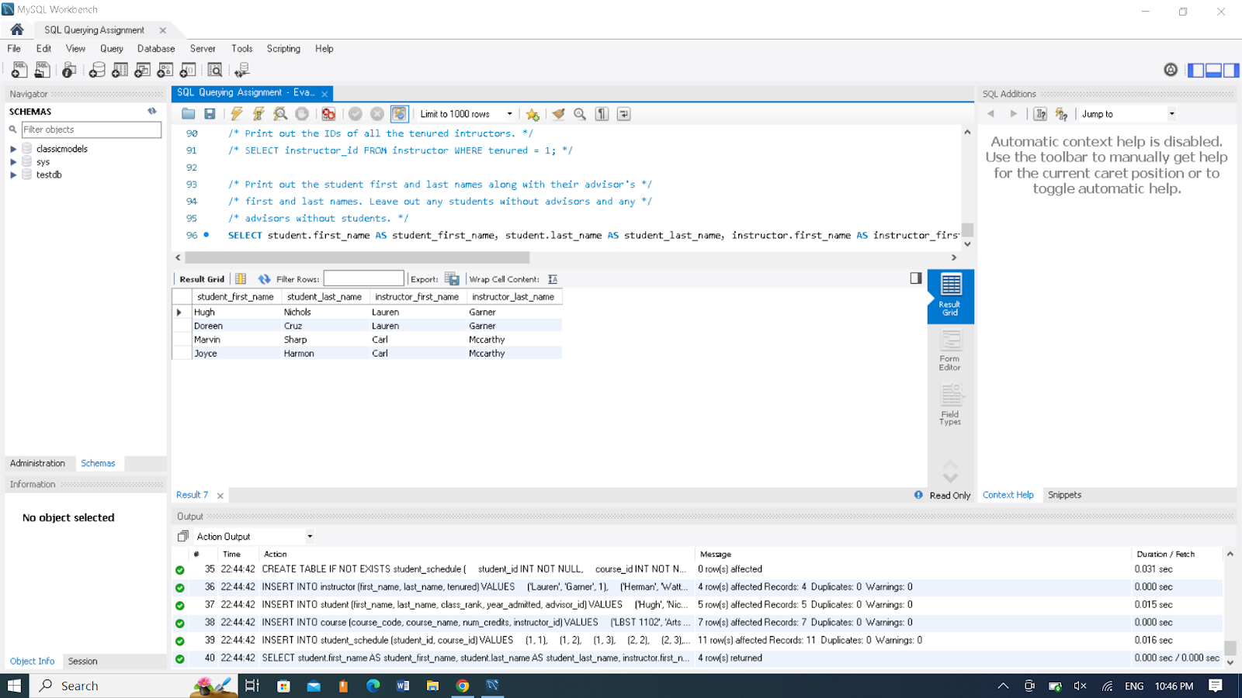

**4. Print out the ID, first name, and last name of all instructors who do not have any advisees.**

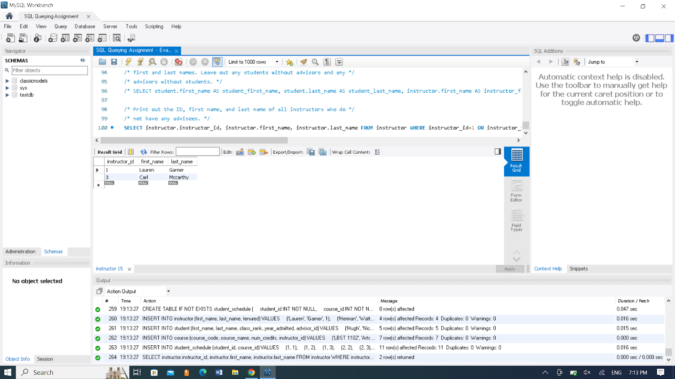

**5. Print out the first and last name of all the instructors along with the total number of credit hours they teach.**

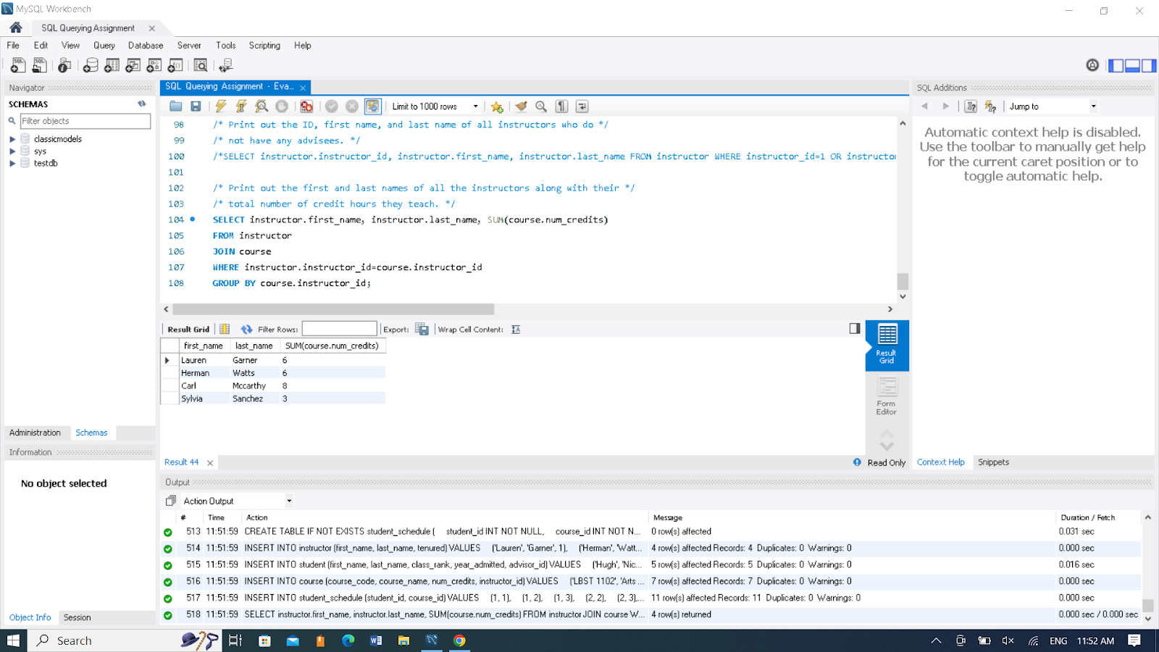

**6. Print out the course code and course name of all the 3000 level courses.**

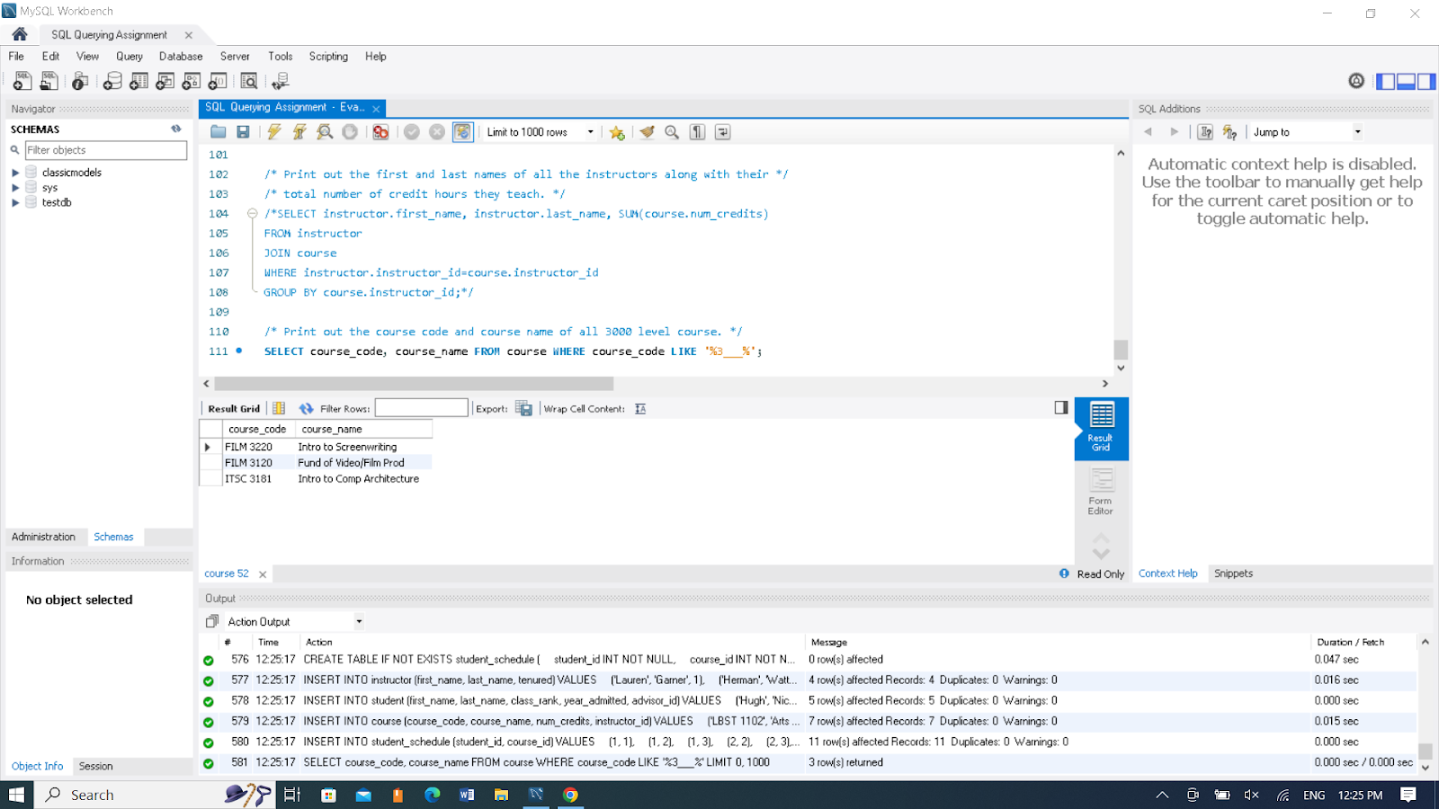

**7. Print course schedule of student with ID of 1 by printing the course code, instructor first name, instructor last name, and number of credit hours for each course.**

